**CityGML Task 3 – part one**

**QGIS 3.4**

QGIS 3.4 loads the **RotterdamLoD1.gml** file but as a point file only.

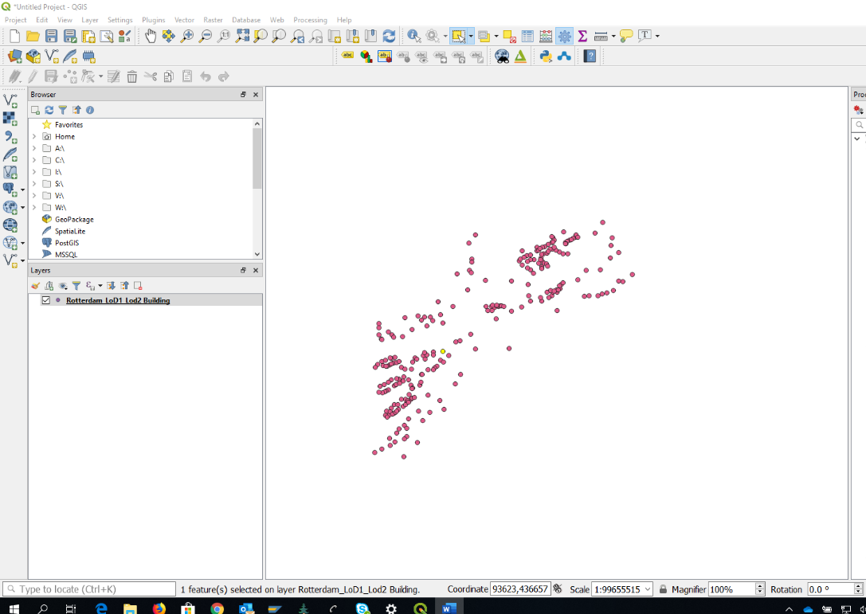

The point file can be given a 3D element using the QGIS plugin Qgis2threejs, but this just renders the points as "bubbles", though in the layer properties this can be changed to a more appropriate shape, such as a box.

The CRS is shown as EPSG:4326 (WGS84) but the project suggests it should be EPSG:25830 (ETRS89 / UTM zone 30N).

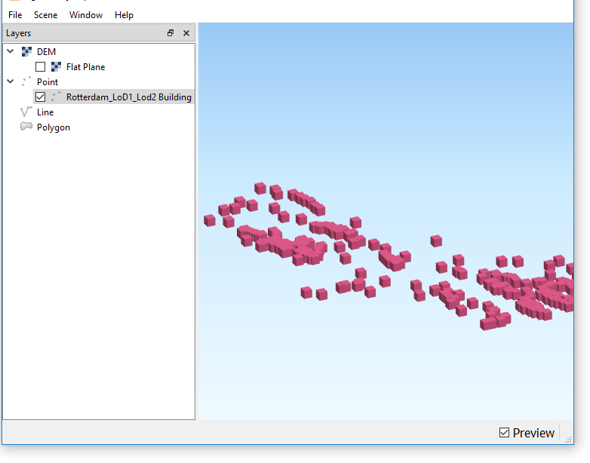

Looking online it appears that a variety of other tools are available to convert the data into a format QGIS will read directly; these include **citygml4j-master** and **cityjson-qgis-plugin-master**.

**citygml4j** requires Java version 8 or above. The project uses [Gradle](https://gradle.org/) as build system to build the program model from source by running commands (<https://github.com/citygml4j/ade-xjc/blob/master/README.md>).

The **CityJSON** loader for QGIS 3 is easy to install but useless without the required data format.

Finding the relevant plug-ins and how to use them could be a blocker for many customers, particularly those with strict software security policies.

Running the data through **FME** to create a json file is time consuming for some of the datasets. The resultant data still throws an error in QGIS and will not load.

Running the data through **FME** to create a Geojson file: Does allow a simple drag and drop with some 3D modelling:

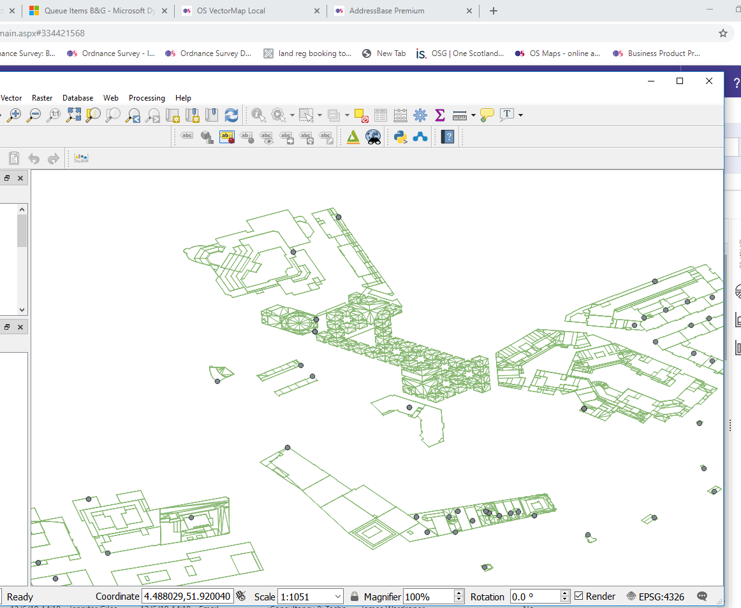

But there are still system messages advising “Error unsupported geometry type”. The data loads quickly and can be panned around quickly too.

Applying the **Qgis2threejs** plugin has no effect with the converted data.

**Builiding LoD3**

The native building LoD3 file loads only as a table file with no geometry.

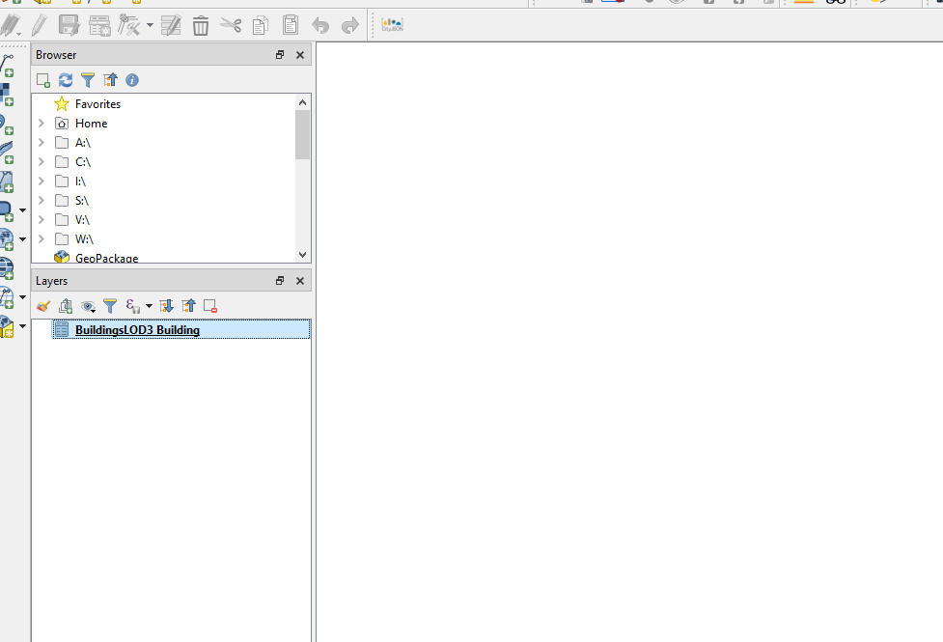

Attribute table below:

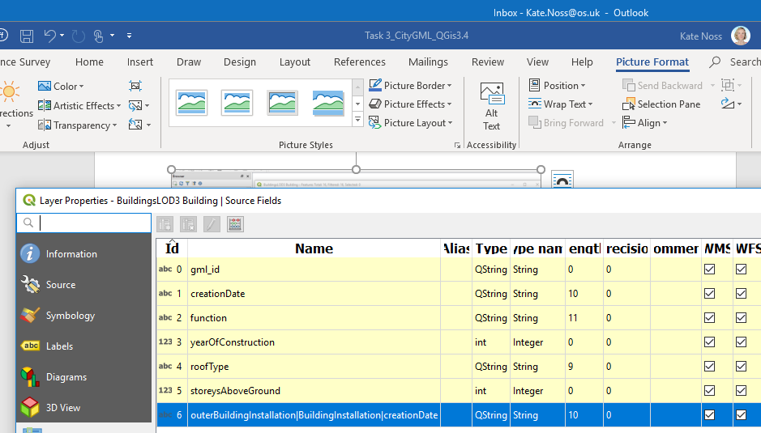

Converted to simple **.json** the data will not load at all.

Converted to **Geojson**, the file can be loaded using simple drag and drop with geometries, none of which are 3D.

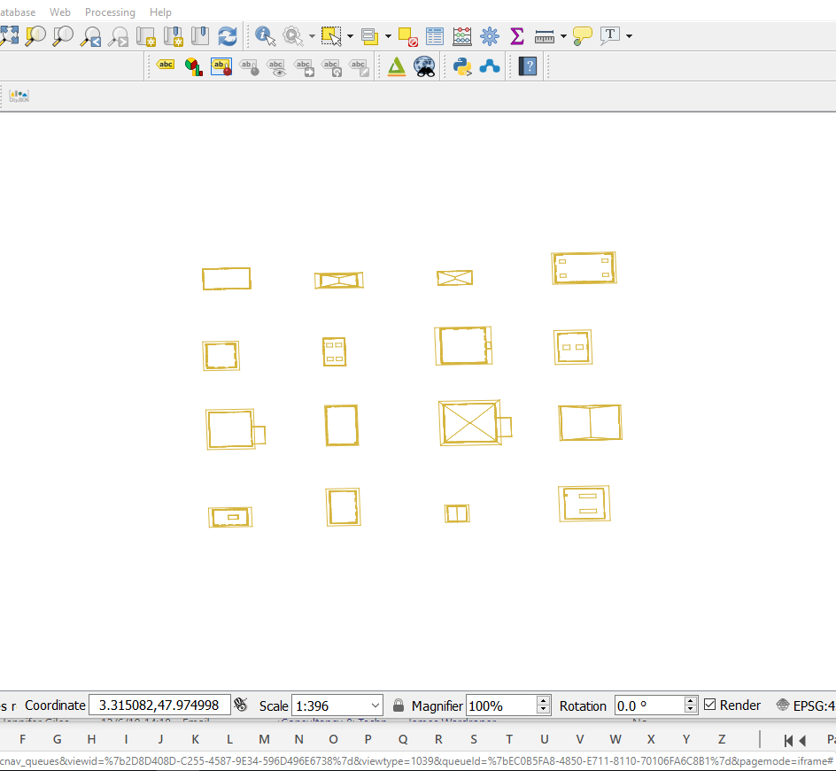

The same qgis plugin, **Qgis2threejs** has no effect with this layer

**Amsterdam LoD1**

Looking at the Amsterdam data, which is used later in the task, the .**gml** loaded with geometries, almost as a mesh (possibly a TIN). The data set is immense and took some length to load (9 minutes) and render.

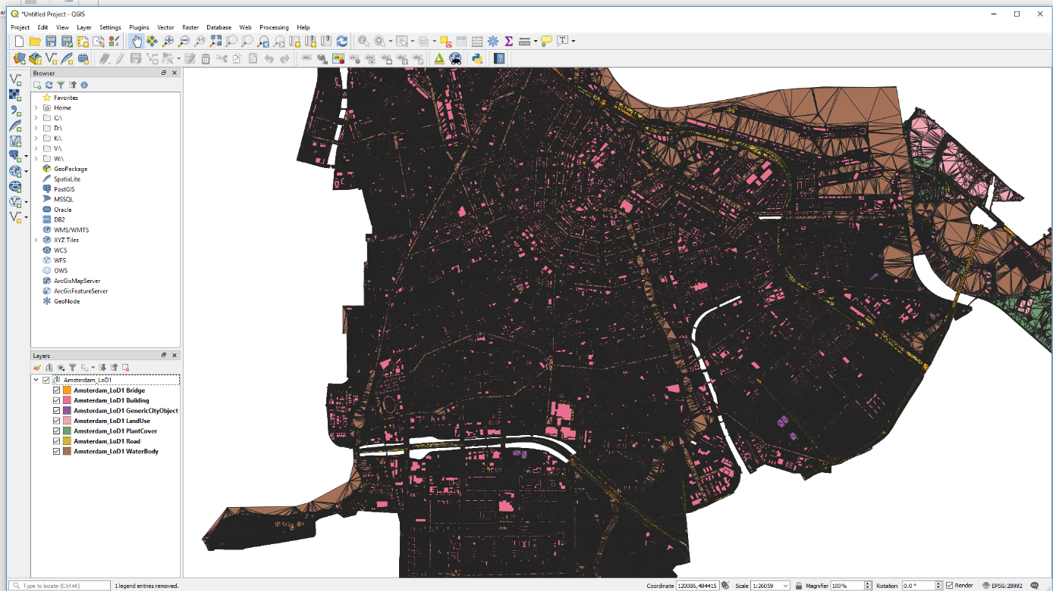

Panning and zooming varies (approximately 3-5 mins for pan and zoom load).

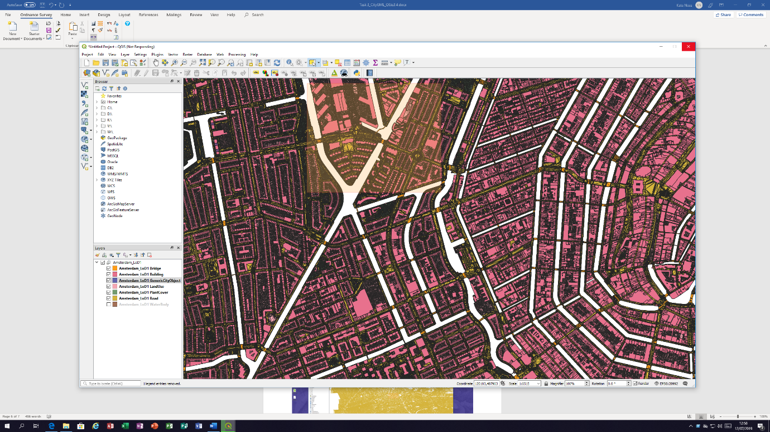

Without further processing the data cannot be visualised as a model, though the same qgis plugin, **Qgis2threejs**, can be applied to create the simple 3D element as with the Rotterdam data above.

I would not recommend trying this with the whole data file, which would almost certainly crash!

Converting the file via FME to **Geojson** took a few hours.

Loading the resultant file took approximately 1hr 15 minutes!

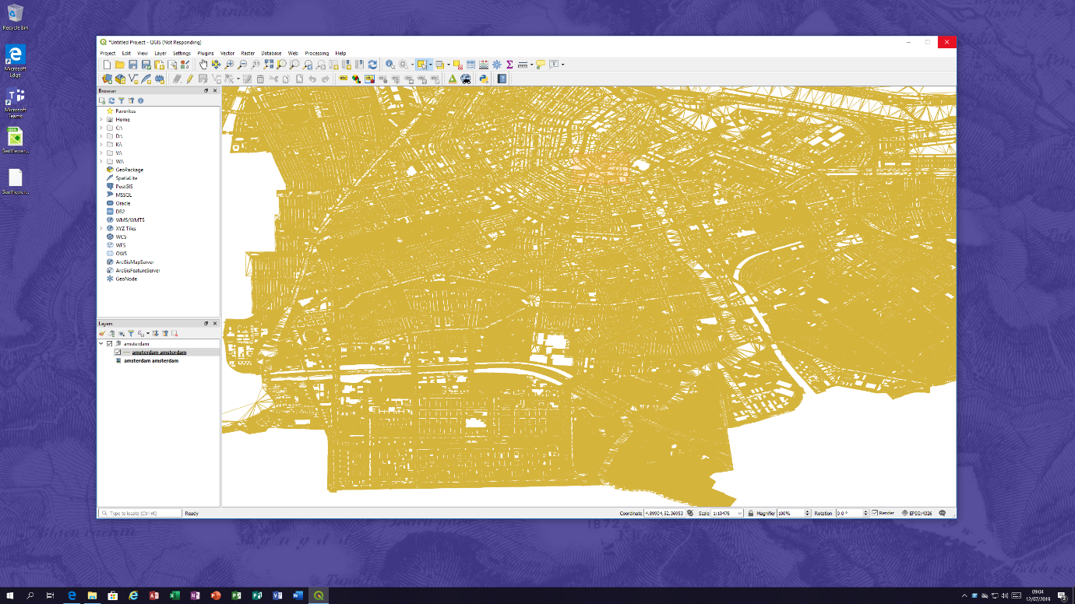

Panning and zooming is equally as painful! However, this does indicate some 3D element.

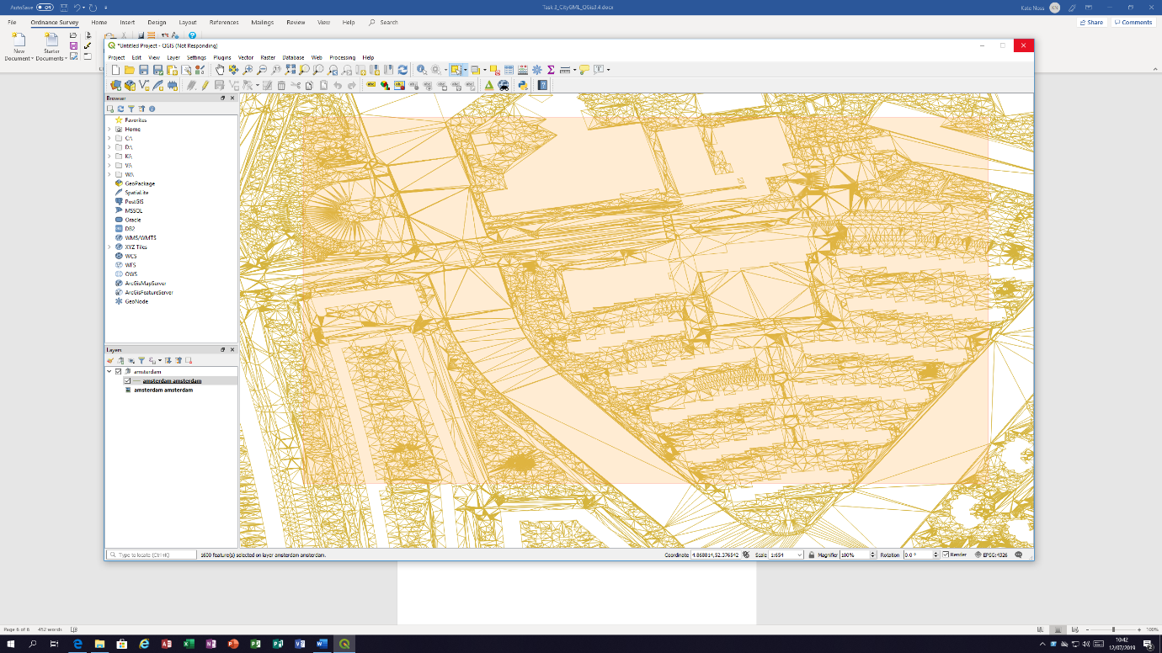

Trying to select a smaller area to export and view is also problematic and crashes. Thus, it has not been possible to test the **Qgis2threejs** plugin with the Amsterdam data after conversion to **Geojson**.

**Conclusion**

For someone with limited experience of GIS, this data is not user friendly. The advertised tools cannot be downloaded easily, as security regulations prevent this;

**citygml4j-master**: <https://www.3dcitydb.org/3dcitydb/citygml4j/>

**Citygml_tools:** <https://www.cityjson.org/help/users/conversion/>

**cityjson-qgis-plugin-master**: <https://www.cityjson.org/about/>

The tools work with java and executable files. Someone with developer skills might find these easy to use, though OS experience of our customer base would suggest a number of our customers would encounter issues.

**ARCGIS PRO.**

ARCGIS Pro does not read the GML data directly either as it will only import .shp or file geodatabase files.

Converting the data via FME to Esri Geojson the file still could **not** be imported.

Exporting the geojson from QGIS 3.4 as a shape file allowed the data to be added to a project in Arc GIS PRO, however, this did not show any data features of any nature.

This exhausted my capability to test the data further.

On the whole I would say anyone wishing to use the data would need to be a seasoned developer to get any valuable results from it based on my experience.